Phenylephrine inhibition of contractions: IC50 = 1E-6M
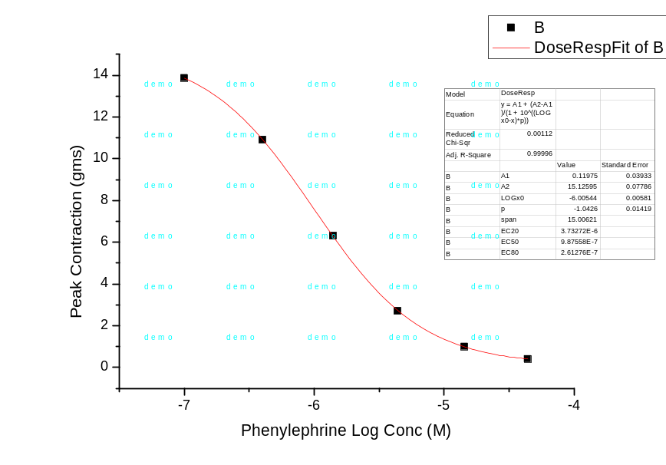

Isoprenaline inhibition of contractions: IC50 = 1.1E-6M
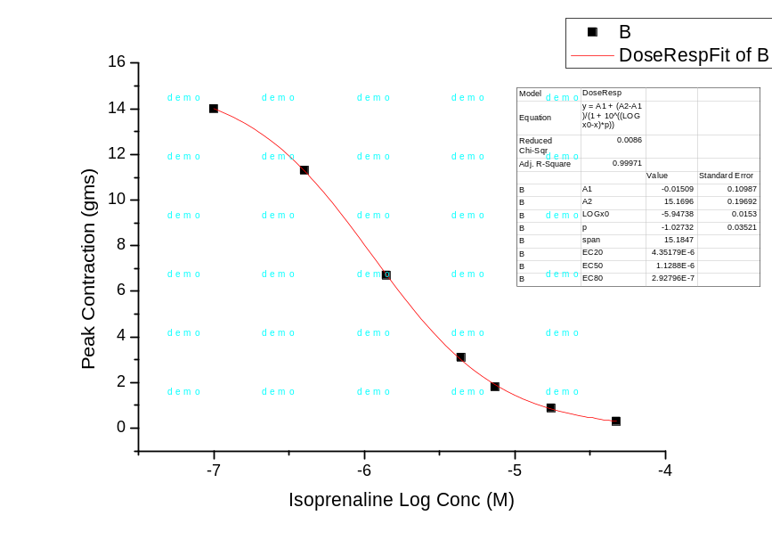

Prazosin block of phenylephrine inhibition (EC50 = 3.6E-7 M)
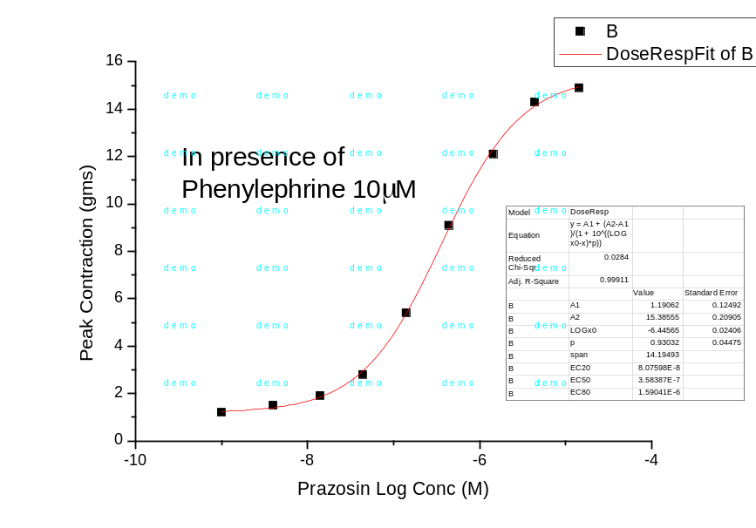

Propranolol block of isoprenaline inhibition (EC50 = 1E-6M)
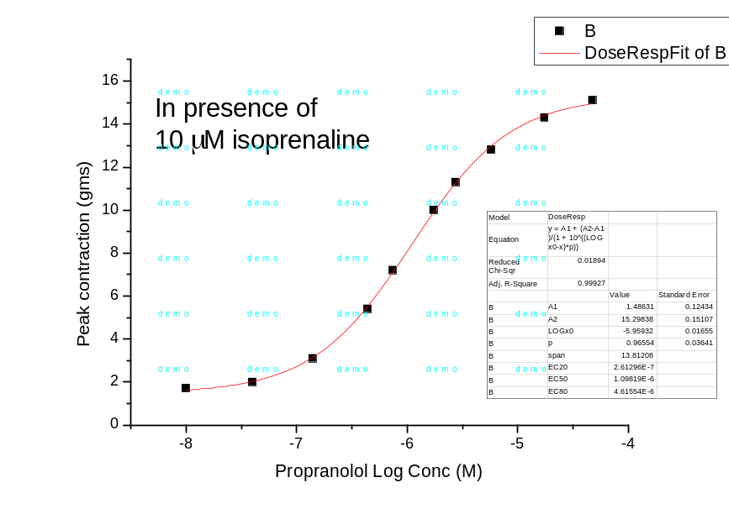

Nerve stimulation
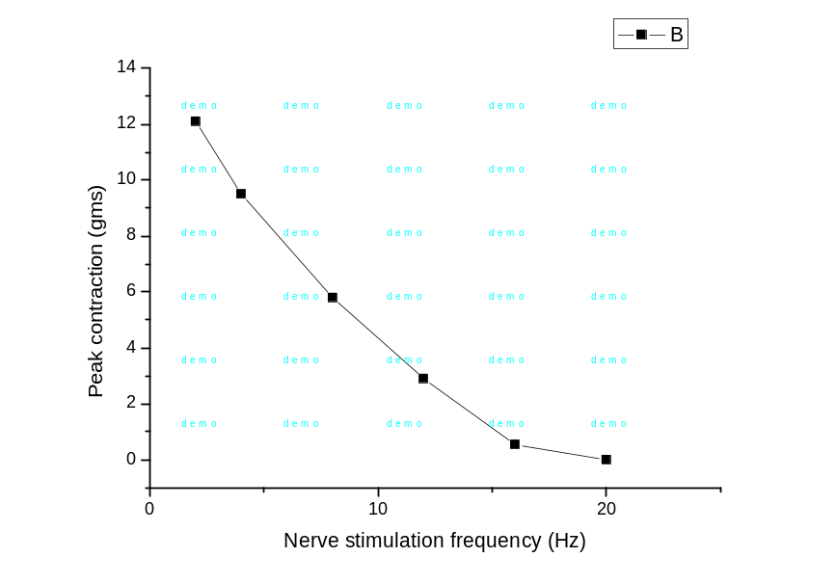

Reversal of 12 Hz nerve stimulation by prazosin 1E-5M, propranolol 1E-5M and prazosin 1E-5M + propranolol 1E-5M
